|  |  |
| --- | --- |
| Assessment Title | Manage ITWorks problem |

## Competency Details

|  |  |
| --- | --- |
| Unit code/s and title/s | ICTSAS527 Manage Client Problems |
| Qualification code/s and title/s | ICT50120 Diploma of Information Technology |
| Business unit/Work group | Business and Arts/IT Studies |

## Instructions

|  |  |
| --- | --- |
| Method/s of assessment | Questioning (Written) and Observation (Role Play) |
| Overview of assessment | This assessment will require you to analyse a client problem to determine the cause and develop a solution. You will then verify the support and resolution requirements to resolve the problem in writing with the client contact, develop and implement a solution. You will then communicate verbally with the client (Lecturer) to seek and act on feedback on the support provided. |
| Task/s to be assessed | This assessment will require you to complete the following tasks   * Task 1 – Review client problem * Task 2 – Plan and implement support * Task 3 – Finalise client problem |
| Time allowed | Refer to your schedule for submission dates |
| Location of assessment | Assessment can be completed anywhere with access to the resources required. (see Resources Required section below)  Task 2.3 role play needs to be completed using Microsoft Teams. |
| Decision making rules | To receive a satisfactory outcome for this assessment you must complete all parts correctly.  Word counts are provided as guidance only. |
| Assessment conditions | This assessment must be undertaken where conditions that are safe and replicate the workplace. Noise levels, production flow, interruptions and time variances must be typical of those experienced in the systems administration and support field of work.  Task 2.3 role play is an observable assessment, your Lecturer will assess you via observation.  All other written tasks are an unsupervised assessment and you may access any required resources.  This is not group work and must be completed as an individual. |
| Resources required | To complete this assessment, you will require the following:   * Access to Learn with Internet access * Learn resources * Office 2016 (365) * Windows 10 * Microsoft Teams * VMWare Workstation * Access to the iTop Service Management System * ASDS – ICTSAS527 Student files.zip * ICTSAS527 Assessment Scenario * ITWorks Work Instruction – Log ICT Incidents and Service Requests * ITWorks Work Instruction – Communication Standards * ITWorks Service Level Agreement * ITWorks Logo * ITWorks User Documentation Style and Standards Guide * ICTSAS527_XanderAlesario Virtual Machine (L:\ITStudies_NAS\Microsoft\VMs\SAS527) |
| Result notification and reassessment information | You will be provided feedback and the result for your assignment on TAFESA Learn. You will be and given the chance to resubmit with required corrections only once.  Refer to the TAFE SA assessment policy for more information <https://www.tafesa.edu.au/apply-enrol/before-starting/student-policies/assessment> |

Refer to the ICTSAS527 Assessment Scenario document prior to starting the following tasks.

**Task 1: Review client problem**

1. According to the ITWorks Service Level Agreement:
   1. What is the response time for this problem and the priority it should be given?

Priority 3 with a response time of 4 hours and target resolution time of 80% 4NWD

* 1. What is the escalation procedure if this problem is not resolved within the target resolution time?

4 hours: Service Desk Manager

If on call contact can not be reached during non-business hours: Service Desk Manager

If neither on call contact or their manager can

not be reached during non-business hours: Service Delivery Manager

48 hours: Service Delivery Manager

* 1. Where did you find this information within the ITWorks Service Level Agreement?

Appendix D

1. Why are Priority Levels, Response Times and Target Resolution Times documented in the ITWorks Service Level Agreement? Provide three reasons (approx. 25 words for each reason).

* Create a mutual understanding of when items should be delivered.
* Defines the responsibilities of each of the parties.
* Provides KPI and the evaluation of processes.

1. The problem is occurring for Xander Alesario,
   1. Who is Xander Alesario in relation to ITWorks?

CEO

* 1. Will you be liaising directly with Xander when resolving his problem as the main contact? Provide an explanation for your response (approx. 25 words for explanation).

No, I will be in contact with his executive assistant, Vera

1. What are the symptoms that Xander is experiencing when trying to access the internet with the Firefox web browser and based on those symptoms what two areas would you focus on to determine the cause of the problem?

Firefox is giving an error of being offline when opening. Closing a reopening firefox does not help.

1. Check to make sure PC has internet access
2. Check settings of firefox and make sure it is set up correctly
3. Analyse the information provided about the problem, access Xander’s PC and find the root cause of the problem. Document your findings below.

|  |  |
| --- | --- |
| **Problem** | **Cause** |
| Firefox opens in offline mode | -offline in shortcut path, or offline mode is turned on in file settings |

1. Email the client contact to confirm support required to resolve the problem. Ensure you construct the email as per the ITWorks Work Instruction – Communication Standards.

***Submit a screen capture of the email (do not send it) to the client contact to “Confirmation of support and resolution email – Task 1 submission” for assessment one. Once you have submitted you will receive an email from Learn with a response from the client contact.***

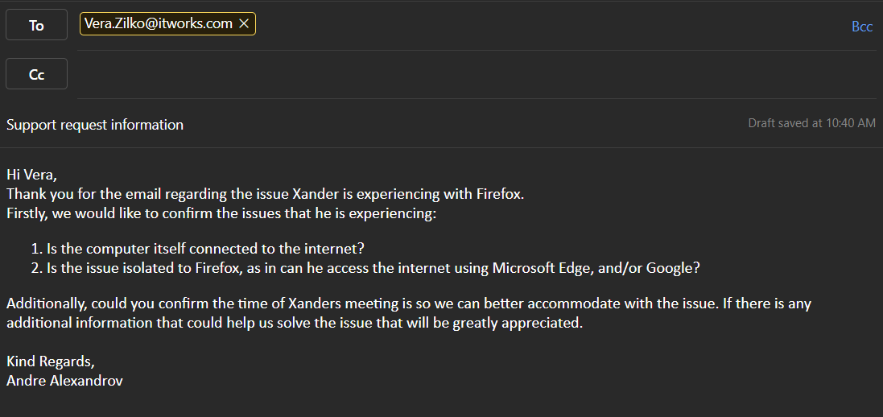

1. Using the ITWorks Work Instruction – Log ICT Incidents and Service Requests, log the problem as an incident in the iTop Service Management system and ensure that you include the following:
   1. Client details and accurate problem description
   2. Any time constraints for the problem
   3. Correct urgency and impact
   4. Your analysis in finding the cause of the problem
   5. Communication with the client

***Provide a screen capture of the ticket logged in iTop***

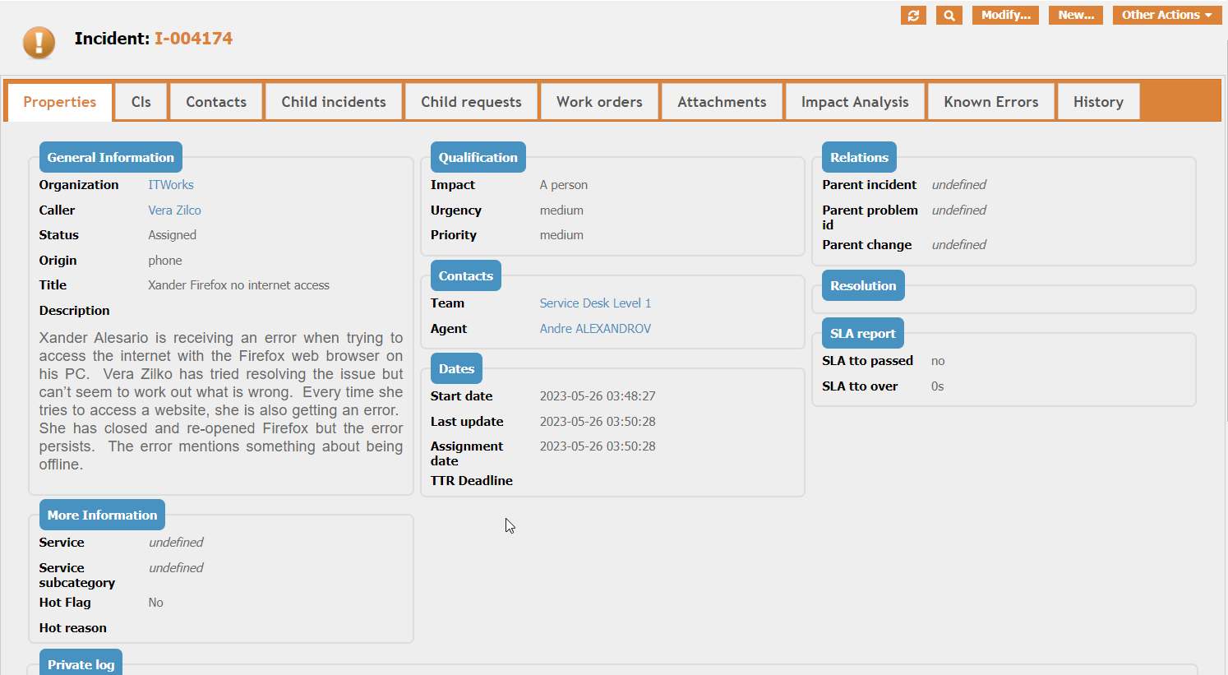

**Task 2: Plan and implement solution**

1. Create a flow chart diagram showing the process you will follow to resolve the problem with Firefox on Xander’s PC. Include your interaction with the client in this process.

The flow chart must contain the following steps at a minimum:

* + - Start and End
    - At least two of each of the following:
      * Decisions
      * Manual operations

** Save the flow chart as a JPG file and insert it here**

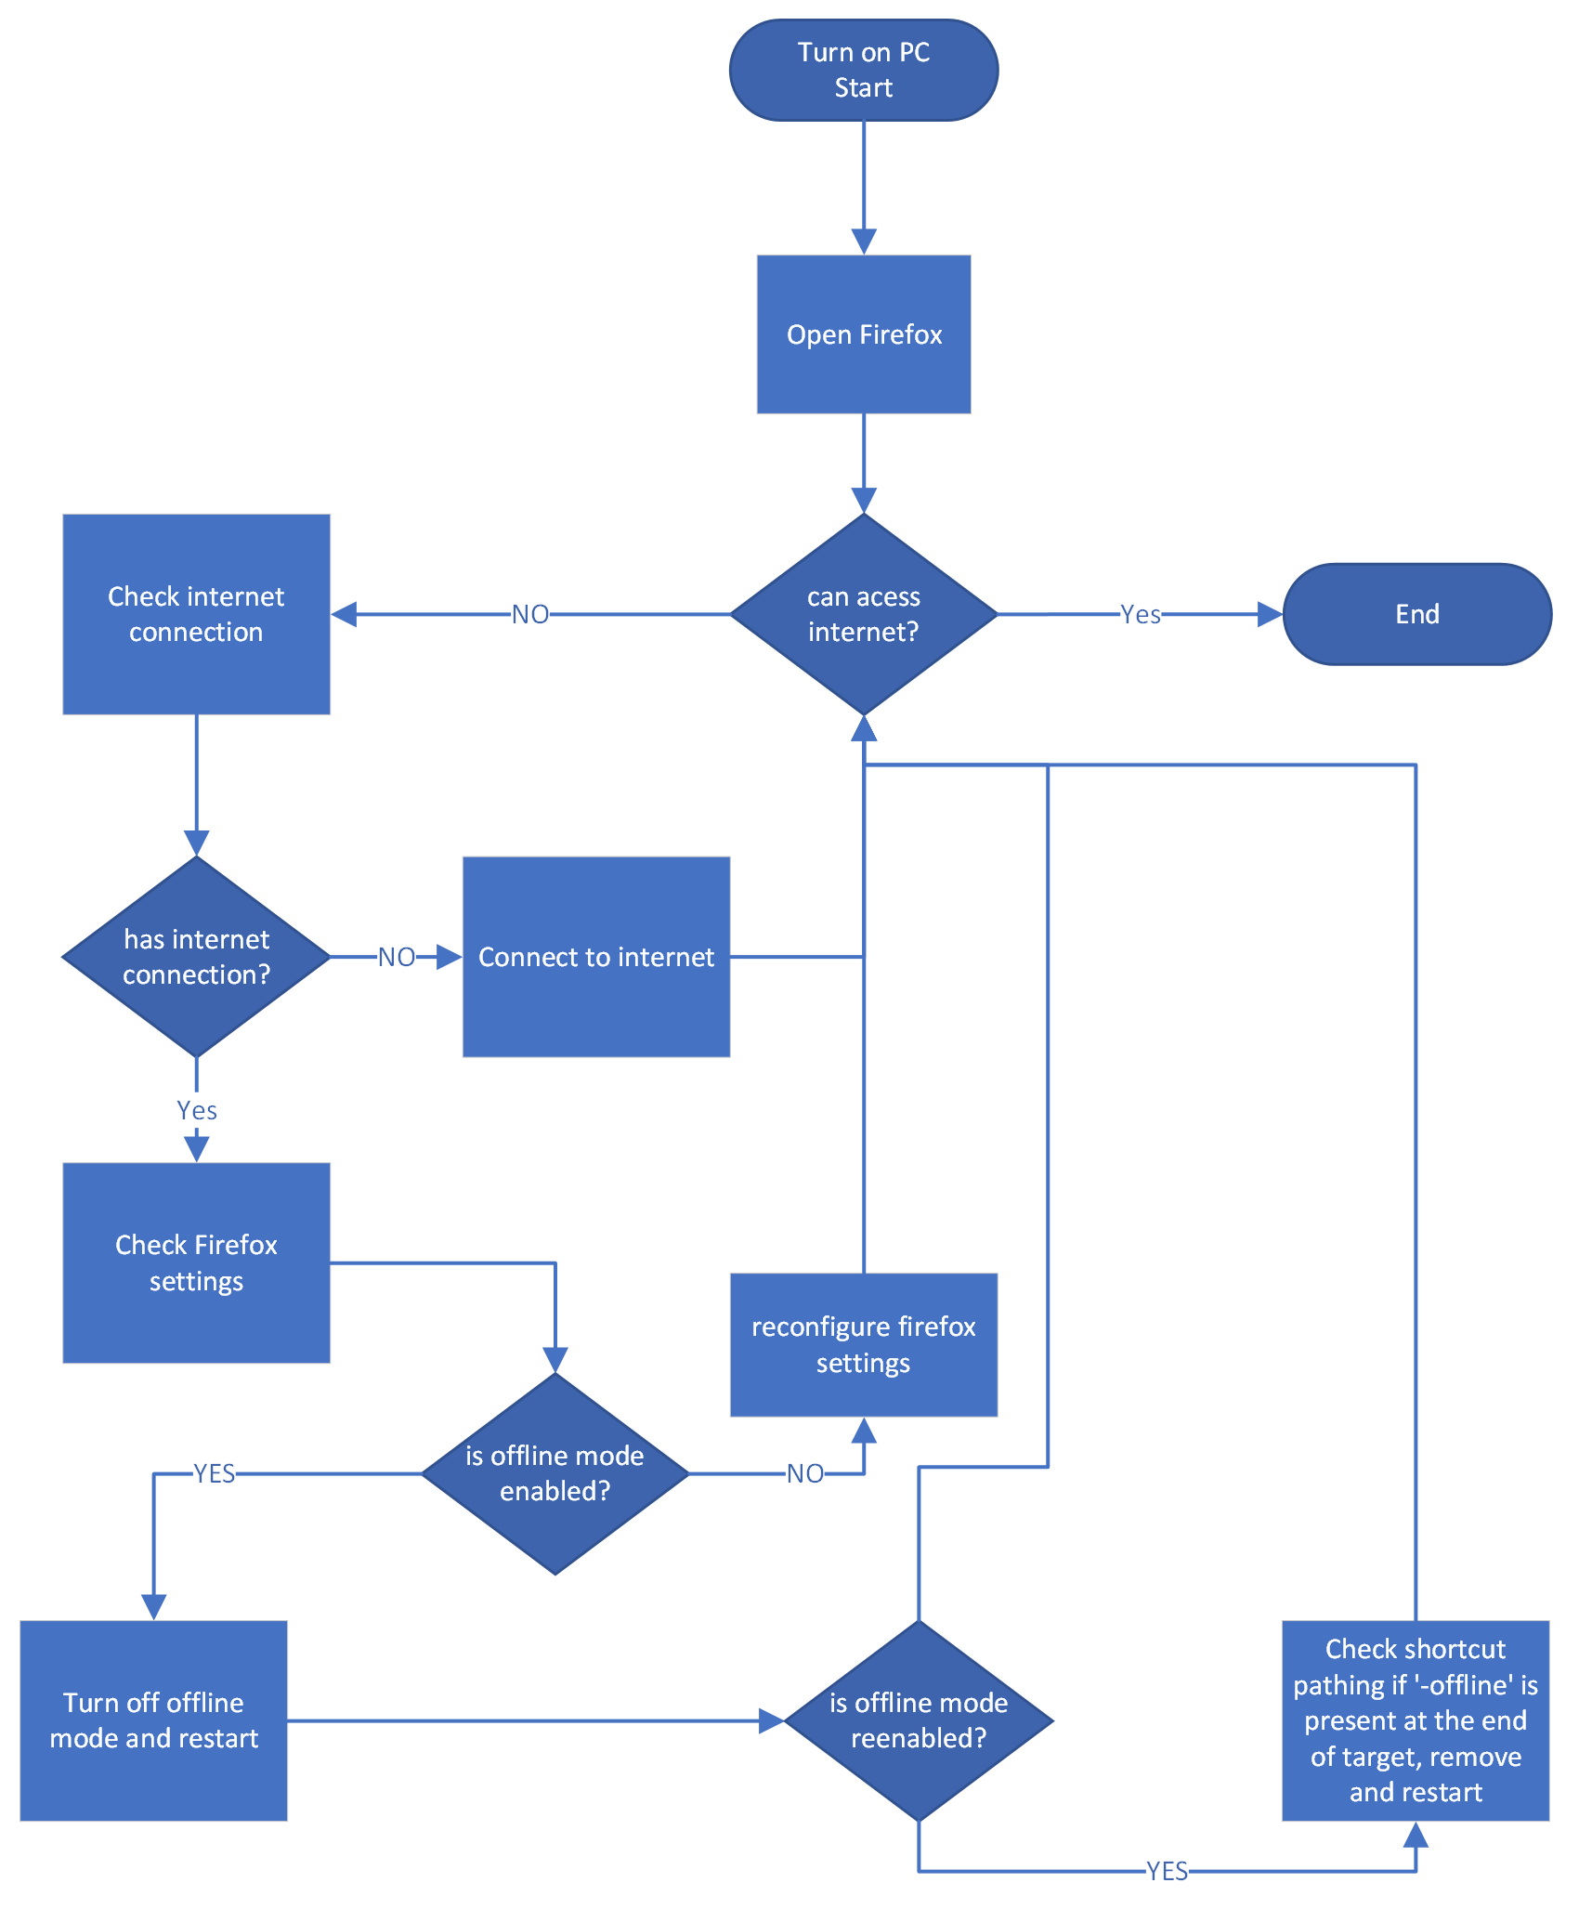

1. Implement the process you have just created to resolve the problem on Xander Alesario’s PC.
   1. Provide comprehensive documentation of your actions and their results in the private log of the ticket in iTop
   2. Test that you can access the following websites with the Firefox web browser in Xander Alesario’s virtual machine:
      * [www.reddit.com](http://www.reddit.com)
      * <abc.net.au>

***Provide screen captures of:***

* ***the updated private log of the ticket with your actions and their results***
* ***accessing the*** [***www.reddit.com***](http://www.reddit.com) ***website***
* ***accessing the*** [***abc.net.au***](abc.net.au) ***website***

1. Call the client contact (Lecturer), to verbally discuss:
   * + - confirmation that the web sites can now be accessed with the fox web browser
       - obtain feedback on the service provided
       - negotiate any additional tasks as a result of the feedback provided from the client

Arrange a time to conduct the call with your Lecturer via email or during your scheduled class time.

Start and stop meeting

Turn on and off webcam

Mute and un mute

How to share screen  
make pictorial quick start guide.

***The call must be conducted via video conferencing using Microsoft Teams to simulate a workplace conversation.***

The role play should be approximately 5 mins.

Ensure that you:

* speak clearly and be succinct
* use listening and questioning techniques to conduct the call
* adhere to the communication guidelines for ITWorks

1. After the call update the ticket and mark it as resolved. Ensure you include all the information from the call.

***Provide a screen capture of the resolved ticket clearly showing your actions in the private log***

**Task 3: Respond to client feedback**

1. Create a request ticket in iTop for the Zoom installation and user documentation as requested from the client contact, include all details provided to you during the call.

***Provide a screen capture of the ticket***

1. Install the Zoom application on Xander’s PC

***Provide a screen capture of the Zoom application installed***

1. Using the ITWorks Style and Standards Guide complete the user documentation for Zoom for Xander.
2. Write an email to the client contact as instructed during your phone call with them providing a draft of the user documentation for Zoom for their review and to seek approval.

***Submit both a screen capture of the email AND the Microsoft Word file of the user documentation to “Zoom User Documentation Review – Task 3 submission”.***

***You will receive feedback from the client contact once your lecturer has marked this submission.***

***If you are marked Satisfactory you can proceed to the next task after completing the additional action requested by the client.***

***If you are marked Not Satisfactory you will need to complete any required edits to meet the requirements of the user documentation AND the additional action requested by the client.***

1. Finalise the user documentation as instructed by the client contact and include this with your submission.
2. Write an email to the client contact confirming that you have finalised the user documentation.

***Provide a screen capture of the email***

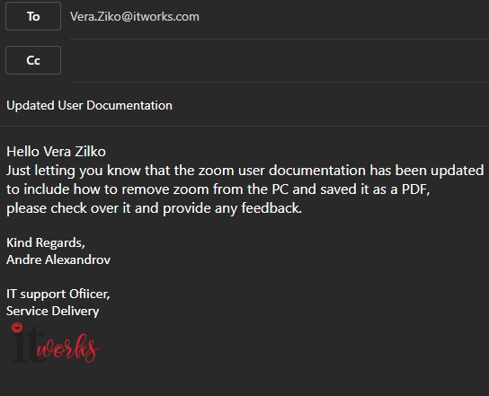

1. Update the private log of the ticket in iTop with all actions you have taken to fulfil the user request.

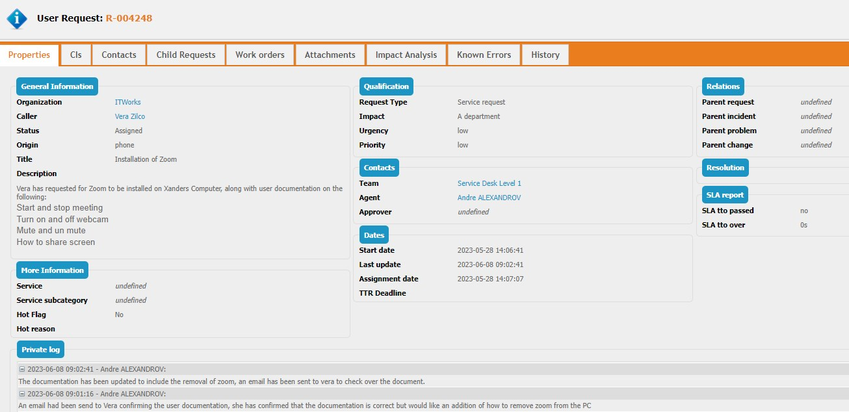***Provide a screen capture of the updated and resolved ticket in iTop***